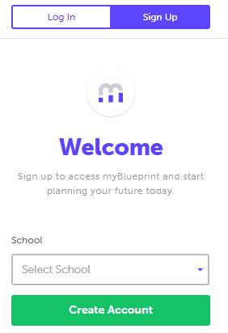
This step-by-step guide will help you complete online course selection using the myBlueprint website.
- EXISTING USER?
- Visit www.myBlueprint.ca/dpcdsb
- Enter your email and password, click Login

- NEW USER?
- Visit www.myBlueprint.ca/dpcdsb
- Select your school from the drop down list and click Create Account
- Select your grade, click Continue
- Enter your Ontario Education Number and Date of Birth, click Continue
- Fill out the sign up form

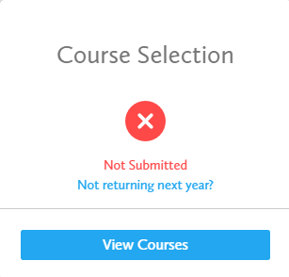
- COURSE SELECTION
From your Dashboard, click on the View Courses button that appears in the Course Selection box at the top left. The button will say Plan Courses if course submission has not yet been enabled at your school.

HINT: Clicking on View or Plan Courses will take you to your High School Planner - you can also access this by simply clicking on High School from the left hand navigation menu.

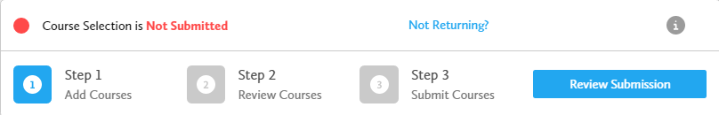

- STEP 1: ADD COURSES FOR NEXT YEAR
  - In High School Planner, click + [Course].
  - In the Course Selection and Details screen, explore the available courses.
  - Click Add Course to Plan when you find the course you want.

The Graduation Indicator will help you keep track of your progress. Click View Progress for a list of specific graduation requirements.

- STEP 2: REVIEW COURSES – When you are ready to submit your course selections, click the Review Course Selections button and give your course selection one final look over.

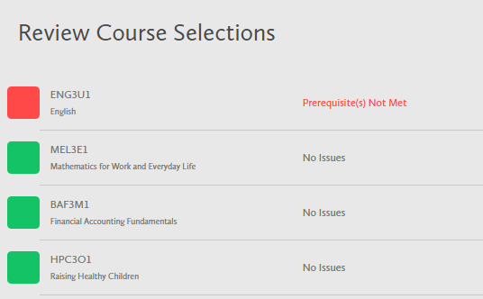

HINT: If available, you can use the comments section to explain any issues to your guidance counsellor (i.e. taking the prerequisite in night school, or summer school, etc).

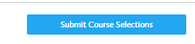
- STEP 3: SUBMIT COURSES – Once you’ve carefully reviewed the Details page to ensure that you are meeting the requirements for the courses you have selected and that the courses that appear are correct, click on Submit Course Selections.

- PRINT SIGN –OFF SHEET
NOTE: The sign-off sheet will show in another tab or window – if it doesn’t show after you’ve click the button, check the pop-up blocker settings for your web browser.

YOU’RE DONE! Print and return a signed copy of your Course Selection Sign-Off Sheet to your Counsellor or Teacher.

